Assignment 12

Question 1 = Write a query that selects all customers whose ratings are equal to or greater than any of Serres.

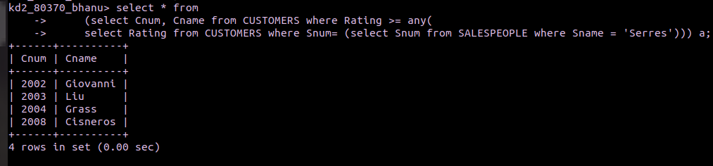
Question 2 = Write a query using ANY or ALL that will find all salespeople who have no customers located in their city.

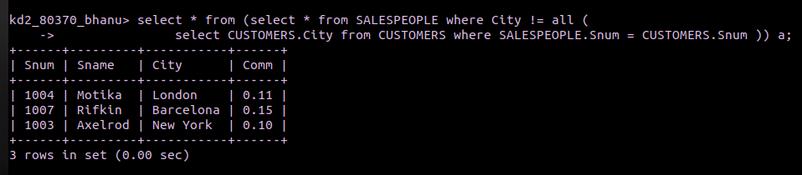
Question 3. Write a query that selects all orders for amounts greater than any for the customers in london

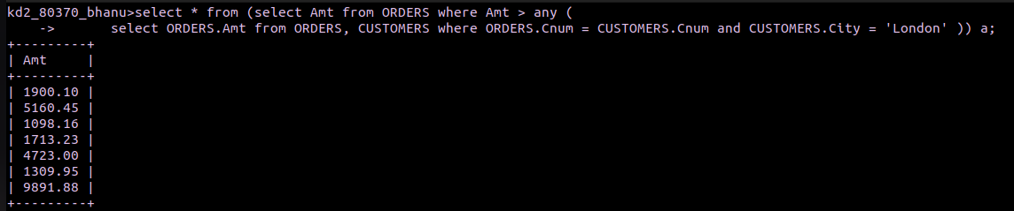

Question 4.Write the above query using MIN or MAX.

